

2025 Annual Report
IHope Christian Care and Counseling
1414 W. Evans St, Florence, SC 29501
www.ihopeflorence.com
Counseling@ihopeflorence.com
843-702-0323

Prepared by iHope Christian Care and Counseling


A Year in Review

We have been blessed in 2025 by the continued opportunity to minister to the community around us in the Pee Dee, but also throughout the state. We have had the chance to see 1187 clients with 118 new clients. We were able to provide 20 scholarships through churches and IHope's scholarship fund totaling over $4000. This included full scholarships from churches, ministry discounts, and our 4 session $25 scholarships.
We were able to take part in opportunities to bless other organizations in our community by contributing to The Care House of Florence's annual 5K Capes for Kids both monetarily and physically and the Florence Police annual golf tournament. We were also able to be present for the annual MUSC Bruce Hall Substance Use Recovery Celebration where we had a table where we shared what we do for those seeking mental health support.
2025 saw a physical change in our building as we updated the wall color and pictures to reflect a calm, welcoming space that our clients spoke highly of as they waited in a space saturated in worship music and God's word on the walls.


Crunching the numbers

Expenses and Revenue

Counseling Hours: 1187
Donations received:
$13,603.40
New Clients:
118
For the year 2025, our revenue was $115,569.96 and our expenses were 111,853.73. Our net income was $3716.23.
We received $13,603.40 in donations which are down from previous years. We have noticed that churches and individuals are not able to be as generous as they have in the past.
We didn't receive any grants although we did apply, and we did receive the first donation from a new 501c3, Pennies for Christ.
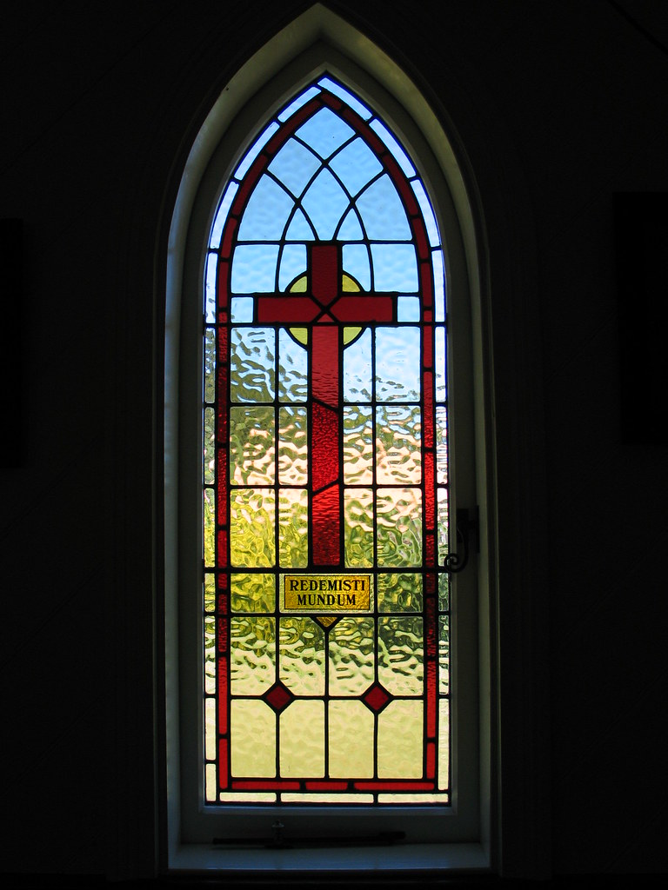
Thanksgiving and Prayers
As ever we are thankful to our Board of Directors, Reeves Canon, Lee Miller, Erika Miller, and Jessica Hayes AND most importantly for all our donors! Prayer Requests Increased donations that will allow us to continue to keep our fees low and scholarships available to those who need them. Our community, Satan is attacking families and we want to be able to continue to be able to help them.

If you are interested in serving on our board, please contact us at the email address given.


And finally,
As the director of iHope I want to take a few lines and say thank you. There are so many people that make iHope the place that it is. From the Board of Directors to even more importantly the counselors, life coaches and receptionists that I have the privilege to minister with, Thank you!
Dr. Denny Bates Dmin, MDiv, Meryl Nesbit, MA, Keith Sikes, LPC, Kevin Deas, MA, LPCA, Jennifer Schelir and Felecia Johnson, our receptionists, and Jordan Conner, LPC who left us at the end of the year.
I am excited to see what the new year will bring, who God will have cross our paths. As I continue to hear about the healing both mentally and spiritually from our clients, I know that God has truly meant for iHope to be a part of the Pee Dee Community. My prayer is that God will always have a place for His people to feel safe and accepted whether Christian or non-believer, and where they can meet Him.
Thank you!
Ruth
Ruth F. Sims, MS, LPCA, BSN, RN
Executive Director
Ruth.Sims@ihopeflorence.com

